电子电工技术

1. Introduction to Electrical Systems
2. Simple DC Circuits

Kirchhoff’s laws

1. 网络图论 Network Theorems
   1. 节点法 Nodal analysis
   2. 叠加原理 Superposition theorem
   3. 戴维南定理 Thevenin’s theorem
   4. 诺顿定理 Norton’s theorem
   5. Delta-star transformation and Star-delta transformation
      1. Delta-star
      2. Star-delta
   6. 最大功率定理 Maximum-power transfer theorem R=r
2. Capacitance and Capacitors
   1. Basic information
   2. Electric field
   3. Growth & decay
   4. Parallel:
   5. Series:
3. Electromagnetism
4. 简易磁路分析 Simple Magnetic Circuit
5. 直流电路中的电感 Inductance in a DC circuit
6. 交流电压与电流 Alternating Voltage and Current

Instantaneous value of e.m.f generated in a coil rotating in a uniform magnetic field:

For sinusoidal waves

1. Single-phase Series Circuits
   1. Alternating current in a resistive circuit
   2. Current and voltage in an inductive circuit
      1. Inductive reactance

1. 单相并联交流电路 Single-phase Parallel Networks
2. 交流电路中的功率 Power in AC Circuits
   1. Active power
   2. Reactive power
   3. Apparent power
   4. Power factor
3. 向量分析法 Complex Notation
4. 交流电路中的谐振现象 Resonance in AC Circuits
   1. AC谐振频率
   2. Q因子 Q factor
      1. 带宽 Bandwith
5. 交流电路中的网络图论 Network Theorems Applied to AC networks
6. 电子系统简介 Electronic Systems
7. 无源滤波器 Passive Filters
   1. 低通 Low pass filter/ lag circuit

In polar form:

At frequency : and

At very high frequency : and

At frequency : and



* + 1. Power drawn from the source



At : P=0

At very high frequency :



At frequency :



is called the *half-power point of frequency*

* 1. 高通 High pass filter/ lead circuit



* 1. 通带 Passband filter



Greater than is passband



* 1. 阻带 Stopband filter



Less than is stopband



* 1. 增益单位：分贝 Gain unit: decibel



* 1. 伯德图 Bode plot

1. 放大器等效电路 Amplifier Equivalent Networks
   1. Amplifier constant voltage equivalent networks

* 1. Amplifier constant current equivalent networks

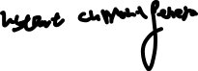

* 1. Feedback

* + 1. Effect fo feedback on input and output resistances

1. 半导体材料 Semiconductor material

1. 整流器 Rectifiers
   1. 半波整流器 Half-wave rectifier

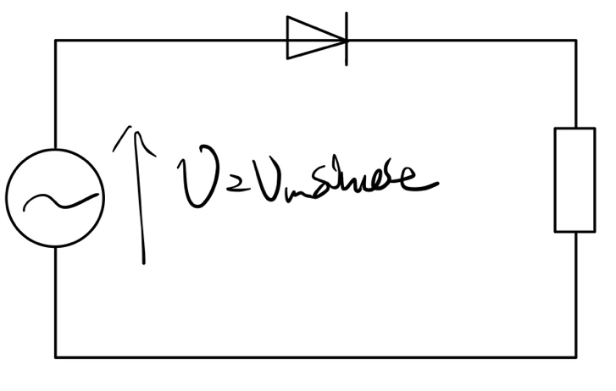

* 1. 全波整流器 Full-wave

* 1. 桥式整流电路 Bridge rectifier network
  2. 滤波 Smoothing

1. Junction transistor
   1. BJT transistor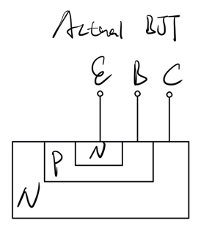图片包含 游戏机, 文字

      描述已自动生成
   2. Classification for BJT
      1. 用极性分
         1. PNP
         2. NPN
      2. 用共性分
         1. Common base
         2. Common emitter
         3. Common collector
   3. Transistor characteristics
      1. Static characteristics
         1. Common base
         2. Common emitter
      2. Current amplification
         1. Common base
         2. Common emitter
      3. Hybrid parameters
   4. Function
      1. Switch
      2. Amplifier

h-parameter for common emitter amplifier:

h-parameter for common base amplifier

1. FET transistor
2. Further semiconductor amplifiers
   1. 级联放大器 Cascaded amplifiers
   2. 运算放大器 Operational amplifier

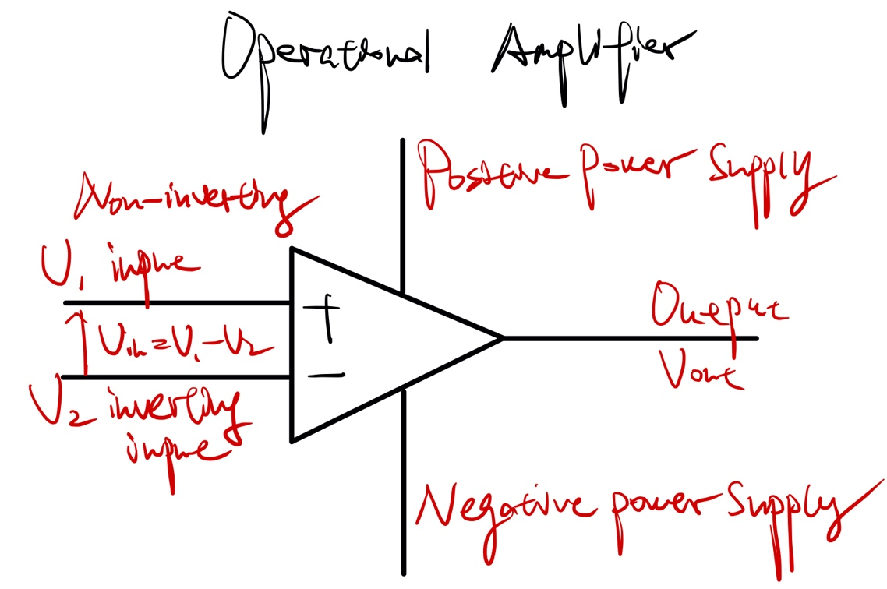

* + 1. 反向放大器 Inverting amplifier

* + 1. 非反向放大器 Non-inverting amplifier

* 1. 加法放大器 Summing amplifier
  2. 差分放大器 Differential amplifier

1. 数模转换接口系统 Interfacing digital and analogue systems
   1. Digital Analogue Convert/DAC Realized by summing amplifier
      1. 最高有效位 Most Significant Bit/MSB
      2. 最低有效位 Least Significant Bit/LSB
   2. Analogue Digital Convert/ADC Realized by op-amp comparator
2. 数字信号基础 Digital numbers
   1. Conversion of binary, decimal and octal. The four fundamental operation of binary.
3. 数字信号系统 Digital systems
   1. 逻辑门 Logic Any logic systems can be represented by three basic gates: or, and, not.
      1. 或门 Or function
      2. 与门 And function
      3. 异或门 Exclusive-Or function
      4. 非门Not function
      5. 或非门 Nor function
      6. 与非门 Nand function
   2. 布尔等式 Boolean identities
   3. 门标准化 Gate standardization
      1. NAND gates as universal gate
      2. Nor gates as universal gate
   4. 卡诺图 Karnaugh maps
   5. 基本储存器 Basic storage elements
      1. SR latch
      2. Clock
      3. SR flip-flop
      4. JK flip-flop